**Assignment Lexical Issues**

1.Code Magnets

**Code:**

**No Clear Pic on CANVAS**

**Output Screenshot:**

2.Write java program to print your name on screen

**Code:**

public class Main2 {

  public static void main(String[] args) {

    System.out.println("Viraj Chhayani");

  }

}

**Output Screenshot:**

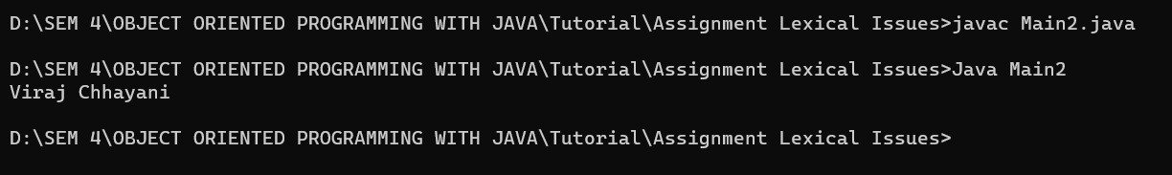

3. Write java program to print "I Like Java, It's Fun" on the screen

**Code:**

public class Main3 {

  public static void main(String[] args) {

    System.out.println("I Like Java, It's Fun");

  }

}

**Output Screenshot:**

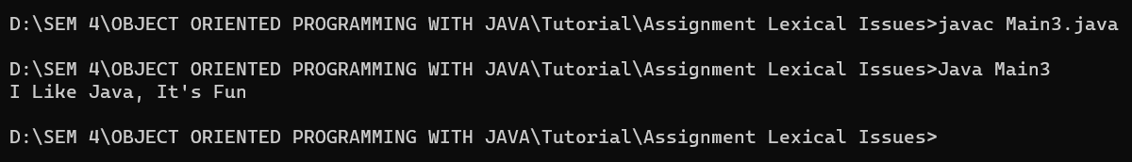

4. Write java program to print your details like name, postal address, education details.

**Code:**

public class Main4 {

  public static void main(String[] args) {

    System.out.println("Name: Viraj Chhayani");

    System.out.println("Address: Jasdan");

    System.out.println("Education: Bachelor of Technology in Computer Engineering");

    System.out.println("           RK University, Rajkot");

  }

}

**Output Screenshot:**

